**User story and use case diagram**

PlantUML code:

@startuml

left to right direction

skinparam packageStyle rectangle

actor User

actor Admin

actor Database

rectangle "ASKDB Interface System" {

User --> (Upload/Select Database File)

(Upload/Select Database File) .> (Validate File Type) : <<include>>

User --> (Ask Question in Natural Language)

(Ask Question in Natural Language) .> (Convert Prompt to SQL) : <<include>>

(Convert Prompt to SQL) .> (Validate SQL against Schema) : <<include>>

(Convert Prompt to SQL) .> (Ensure SQL Safety) : <<include>>

User --> (Run SQL Query)

(Run SQL Query) --> Database

Database --> (Return Results)

User --> (Edit SQL)

(Edit SQL) .> (Run SQL Query) : <<extend>>

User --> (Export Results)

(Export Results) --> (CSV/JSON)

User --> (View Query History)

(Handle Errors) <.. (Ask Question in Natural Language) : <<extend>>

(Handle Errors) <.. (Run SQL Query) : <<extend>>

Admin --> (Manage Database Files)

}

@enduml

Use case diagram:

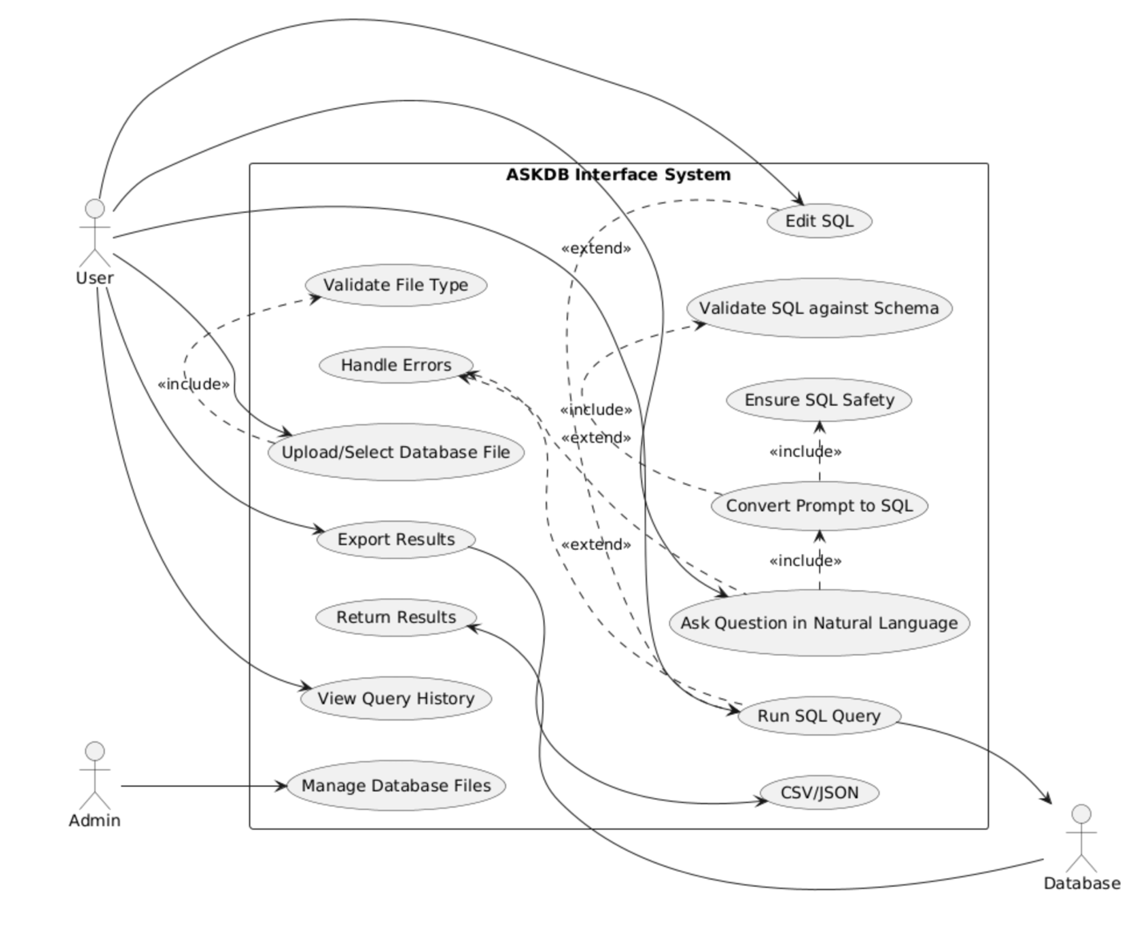

User story :

User Stories for ASKDB Interface System

As a user:

1. I want to upload a database file, so that I can start exploring data.
2. I want the system to validate the database file type, so that I don’t upload unsupported files.
3. I want to ask questions in natural language, so that I can get insights without writing SQL manually.
4. I want the system to translate my question into SQL, so that I can retrieve the correct data.
5. I want the system to ensure SQL queries are safe, so that no harmful queries are executed.
6. I want the system to validate queries against the database schema, so that I get reliable results.
7. I want to see the generated SQL, so that I can understand and optionally edit it.
8. I want to execute the SQL query on the database, so that I can retrieve results.
9. I want to see results in a user-friendly table format, so that I can easily interpret the data.
10. I want to export results to CSV or JSON, so that I can share or reuse the data.
11. I want to view my query history, so that I can repeat or refine past queries.
12. I want to receive clear error messages when something goes wrong, so that I understand what to fix.
13. *(Nice-to-have)* I want auto-suggestions while typing, so that I can write prompts faster.
14. *(Nice-to-have)* I want the system to explain the generated SQL, so that I learn how queries are formed.
15. *(Nice-to-have)* I want a chat-style interface with follow-ups, so that I can refine my queries naturally.